AMIS|Conclusion SIG Workshop

Data Wrangling with Jupyter Notebooks

21st February 2019

Data Wrangling is a crucial stage in the data science workflow. Or in any workflow that starts from raw data and hopes to achieve business insight – and perhaps ready to run well trained machine learning models. Data wrangling encompasses various steps and activities -from gathering raw data, exploring, validating, filtering, filling in missing values, joining, enriching, aggregating, shape shifting, unifying. No clear break may be apparent between gathering, preparing, exploring, visualizing and modelling the data. These are iterative steps – with data wrangler moving back and forth in the process.

One of the most used data wrangling workbenches is the Jupyter Notebook – most commonly powered by a Python engine and leveraging the many libraries and frameworks that make the Python ecosystem such an attractive place for data professionals. In this workshop, you will get an introduction to Jupyter Notebook and Python – a platform for Data Analytics (data wrangling, visualization, reporting and machine learning). We will start with getting going with your very own Jupyter Notebook environment, running in a Docker container either locally on your laptop or on a cloud environment. Then you will get acquainted with a simple introduction notebook and subsequently work through a predefined notebook for a somewhat more complicated business case. Finally, you are on your own. We will give some suggestions for next steps – creating your own Notebook and finding answers to business questions on your own.

Of course, the time we have is limited and the scope is potentially vast. So we will barely scratch the surface of both the area of data wrangling as well as the use of Jupyter Notebooks and Python as workbench. However, you will probably get a good inkling of what they have to offer and hopefully get you enthusiastic and inspired to take it from here and move forward.

In this workshop:

* Get access to a Jupyter Notebook environment; you can choose between two options
  + Run Jupyter Notebook in a Docker container on your own laptop
  + Make use of the declarative, cloud based Katacoda playground that does not require any local installation (in fact, only requires you to have a browser and internet access)
* Get acquainted with Jupyter Notebook in an introductory (“Hello World” style) notebook
* Explore the case of the Oracle OpenWorld & CodeOne session catalog using predefined, ready to run notebooks
  + And perhaps tweak and extend these notebooks a little
* On your own: get started on your very own Jupyter Notebook.

### Resources

Sources for this workshop: <http://bit.ly/conclusion-notebook>   
(this is short for:  
<https://github.com/lucasjellema/DataAnalytics--IntroductionDataWrangling-JupyterNotebooks> )

# 1. Prepare your Jupyter Notebook environment

As stated before, you can choose between two options. One requires some experience with Docker and a fairly powerful laptop on which you can install software and run virtual machines. The other one requires nothing from you besides a browser – and leads you through a number of declarative, very low code steps. However, the environment you create in this scenario will exist only for a few hours, whereas the environment you install locally is yours for as long as you want.

For the declarative, browser-based environment (leveraging the Katacoda platform) – go to *Appendix C*. Next, continue with Chapter 2.

## Local installation of Jupyter Notebook on Docker

The sources for this workshop are in a GitHub Repo: <https://github.com/lucasjellema/DataAnalytics--IntroductionDataWrangling-JupyterNotebooks> . Among these sources are some scripts we will use for preparing the local Docker container. As a first step, please perform a git clone of this repository to your local file system – from the command line on your laptop in a suitable directory of your choosing.

git clone https://github.com/lucasjellema/DataAnalytics--IntroductionDataWrangling-JupyterNotebooks

This will download a number of sources to your laptop. We will be using some of them shortly.

Note: if this command fails – you may not yet have a Git client installed on your laptop. In that case, please go to <https://gitforwindows.org/> (for Windows) or <https://git-scm.com/download/mac> (for Mac) and download and install the Git client. Then execute the *git clone* command again.

This local scenario comes in at least two flavors – depending on how you want to run Docker containers. We will discern between two situations:

* Use Vagrant and VirtualBox to create a Linux VM that acts as Docker engine – see *Appendix A* for further instructions
* Run Docker containers natively on Windows using Docker for Windows and leveraging Hyper-V (not compatible with Virtual Box) – see *Appendix B* for instructions

If you do not currently use Docker for Windows or Windows Hyper-V, it is recommended to go for the first option – using Virtual Box and Vagrant.

# 2. Get acquainted with Jupyter Notebook - Hello World notebook

From the Jupyter Notebook client running in your browser, open the file [*HelloWorldNotebook.ipynb*](http://192.168.188.144:8888/notebooks/work/HelloWorldNotebook/HelloWorldNotebook.ipynb) notebook, from the */work/HelloWorldNotebook* folder.

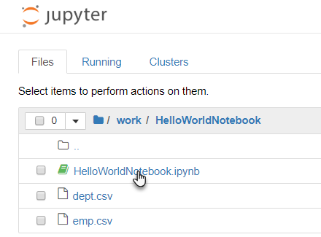

This notebook introduces you first of all to notebooks: how a notebook contains cells of two types (markdown for text and code for Python code) and how each cell can be executed (CTRL+Enter, the Run icon in the toolbar). You can create a new cell by clicking the + icon in the toolbar.

Please follow the instructions in the notebook: create new cells, copy the indicated code to the cell and execute the cell. Feel free to experiment: make changes to the code or simply type your own.

After the first set of cells, you will hit the section *Loading Data into a Pandas Dataframe*. This section is an introduction to the Pandas library (Paneled Data) – a library for data wrangling, data exploration, manipulation, visualization and analysis.

Most of the notebook will work with the employees data set (based on the EMP and DEPT tables in the SCOTT demo schema in early Oracle Database versions). Before you start working with this data set in the notebook, you can inspect it by opening the emp.csv file in your browser:

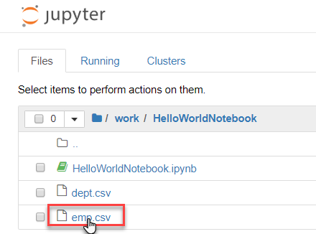

The file’s content is not very special and easy to interpret: 14 employees with an identifying number, a name, a job and manager, a hiredate and salary, for some a commission and for all a department number.

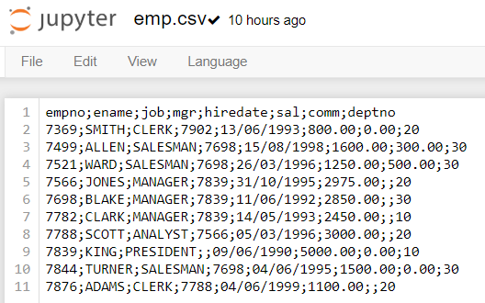

Follow the instructions in the notebook – from loading the dataset into a Pandas data frame to the wrangling and visualization, producing for example this chart (in a single line of code):

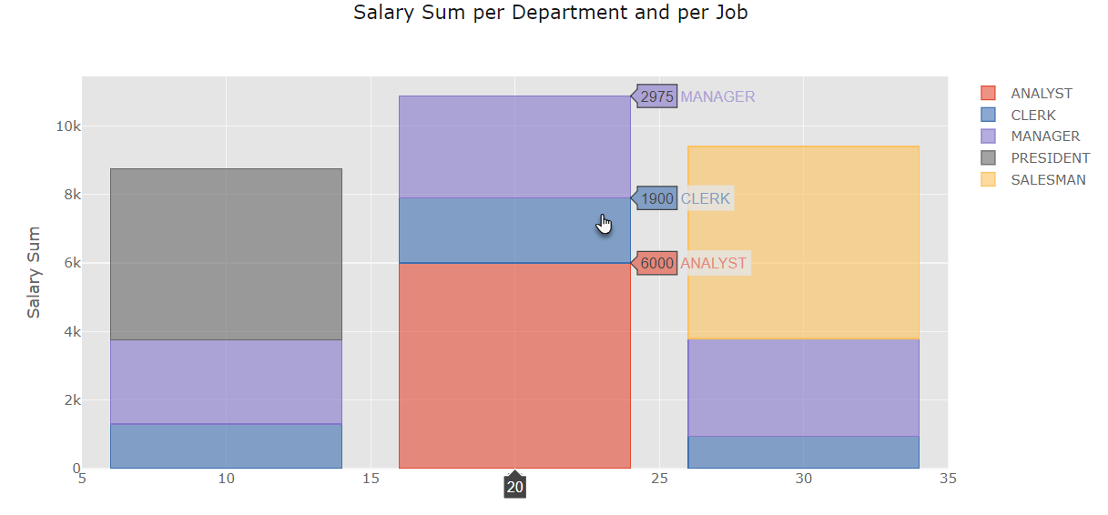

The notebook as a final Resources section with some references to documentation and tutorials on Notebooks and Pandas.

# 3. Explore the case of the Oracle OpenWorld & CodeOne session catalog

Oracle OpenWorld 2018 was a conference that took place in October 2018 in San Francisco. Over 30,000 attendees participated and visited some 2000 sessions. In this section, we will explore some of the data around this event. We will take a closer look at the speakers and their origin and at the sessions: what are they about, how are they tagged, what are their target audiences and how are they scheduled logistically?

Raw data from the session catalog is available from an API – a REST service that is consumed by the Session Catalog Web UI. This API does not seem intended for data analysts such as we. The data is not in great shape.

The next figure illustrates the steps we will go through in order to get from raw data to answers to burning questions about Oracle OpenWorld 2018 and the collocated CodeOne conference.

From the raw source, we will gather the data into our local datalake. Next, we will wrangle this data – whip it into shape, filter, cleanse, enrich it so it is easily usable for business intelligence and data science tasks such as machine learning.

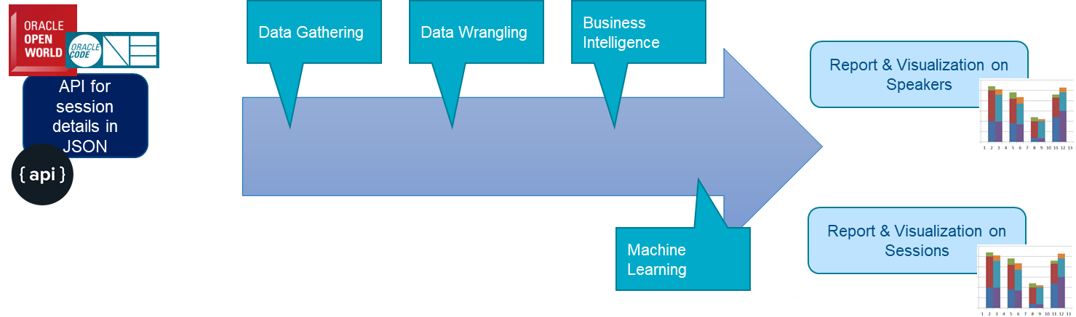

We will use various Jupyter Notebooks – powered by Python – to go through these four stages:

* 1-OOW2018 Session Catalog - retrieving raw session data in JSON files
* 2-OOW2018 Session Catalog - Wrangling I - one single, refined, reshaped file
* 3-OOW2018 Session Catalog - Business Intelligence Speakers
* 4-OOW2018 Session Catalog - Business Intelligence Sessions

The next figure gives a high level overview of what each of these notebooks does:

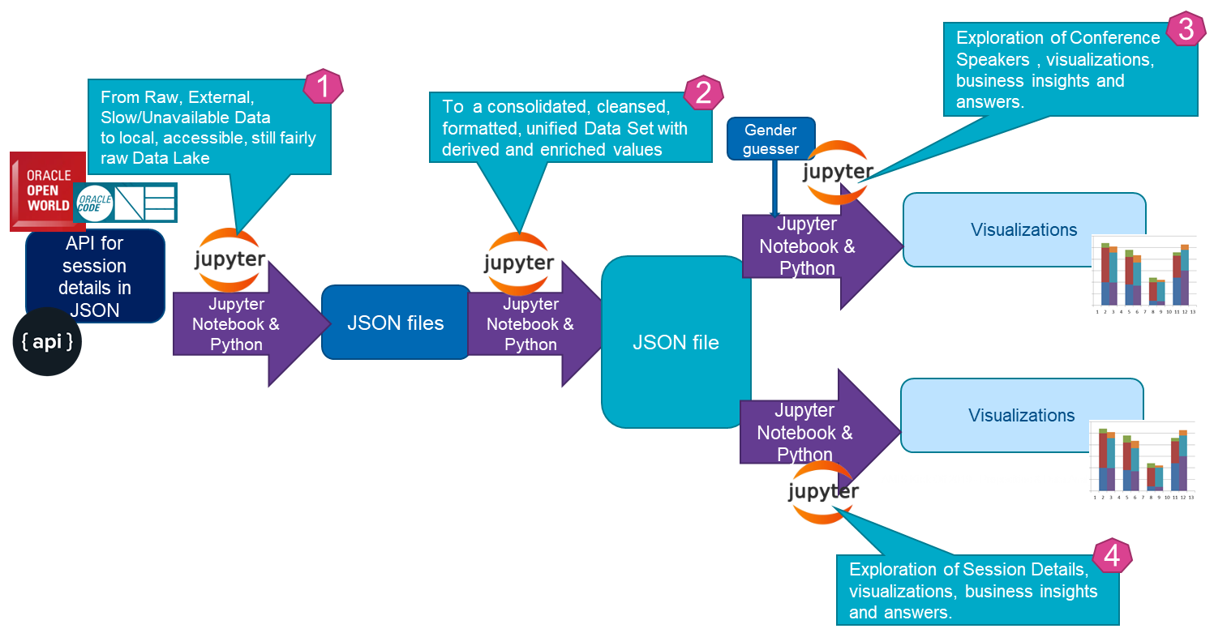

## 1-OOW2018 Session Catalog - retrieving raw session data in JSON files

From the Jupyter Notebook client running in your browser, open the file *1-OOW2018 Session Catalog - retrieving raw session data in JSON files.ipynb* notebook, from the */work/CaseOfOracleOpenWorld2018* folder.

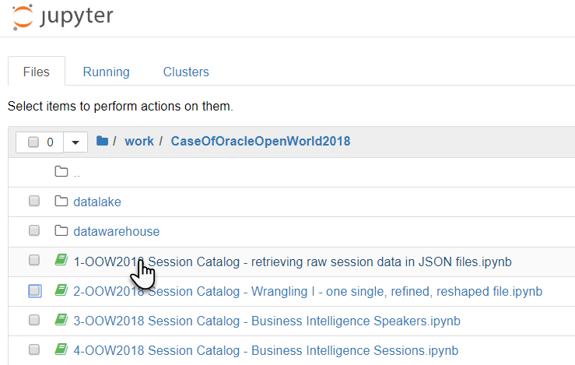

Note: you do not actually need to run this notebook, although you can. Its final output is already available in the */datalake* folder. You can simply browse through the notebook to see how the data retrieval and local storage is done.

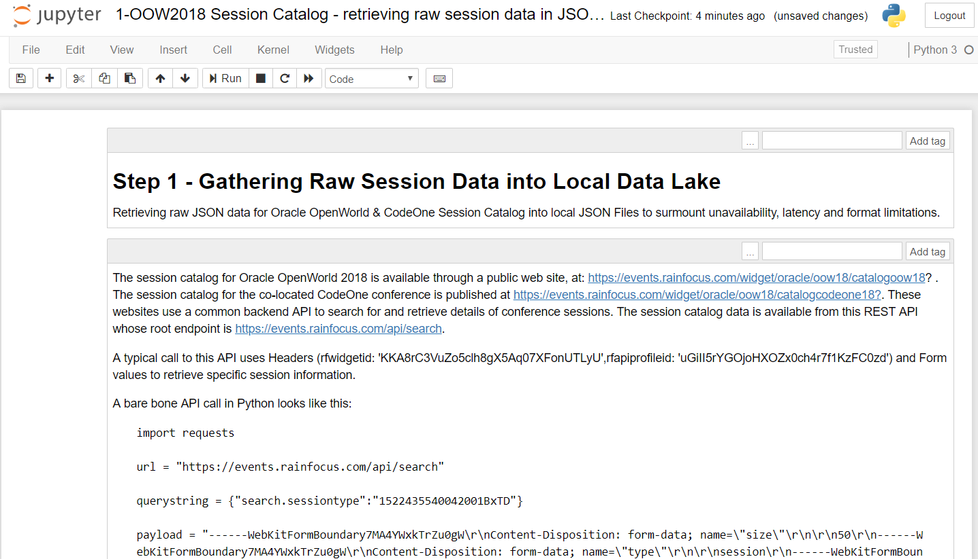

This notebook retrieves the raw data from the remote API – using subsequent HTTP REST requests. The data is gathered using calls per session type (22 different types), per event (two events – Oracle OpenWorld and CodeOne) and per batch of 50. This means that close to 60 HTTP calls are made. The resulting data is in JSON format. This data is written to local files per event and session type (44 in total) in the folder */datalake*.

By perusing the notebook, you will get an idea of how to perform REST calls, how to process the response body and JSON data content, how to turn JSON content in a Pandas Data Frame and how to write the content of such a Data Frame to a JSON file on disk. You will get a glimpse of the raw data. In the next section, we will discuss the Jupyter Notebook that does the main data wrangling, to turn this raw, not very accessible set of data files into a single, refined data warehouse that will be to the delight of data analysts.

## 2-OOW2018 Session Catalog - Wrangling I - one single, refined, reshaped file

Open the notebook *2-OOW2018 Session Catalog - Wrangling I - one single, refined, reshaped file.ipynb* into your Jupyter Notebook client.

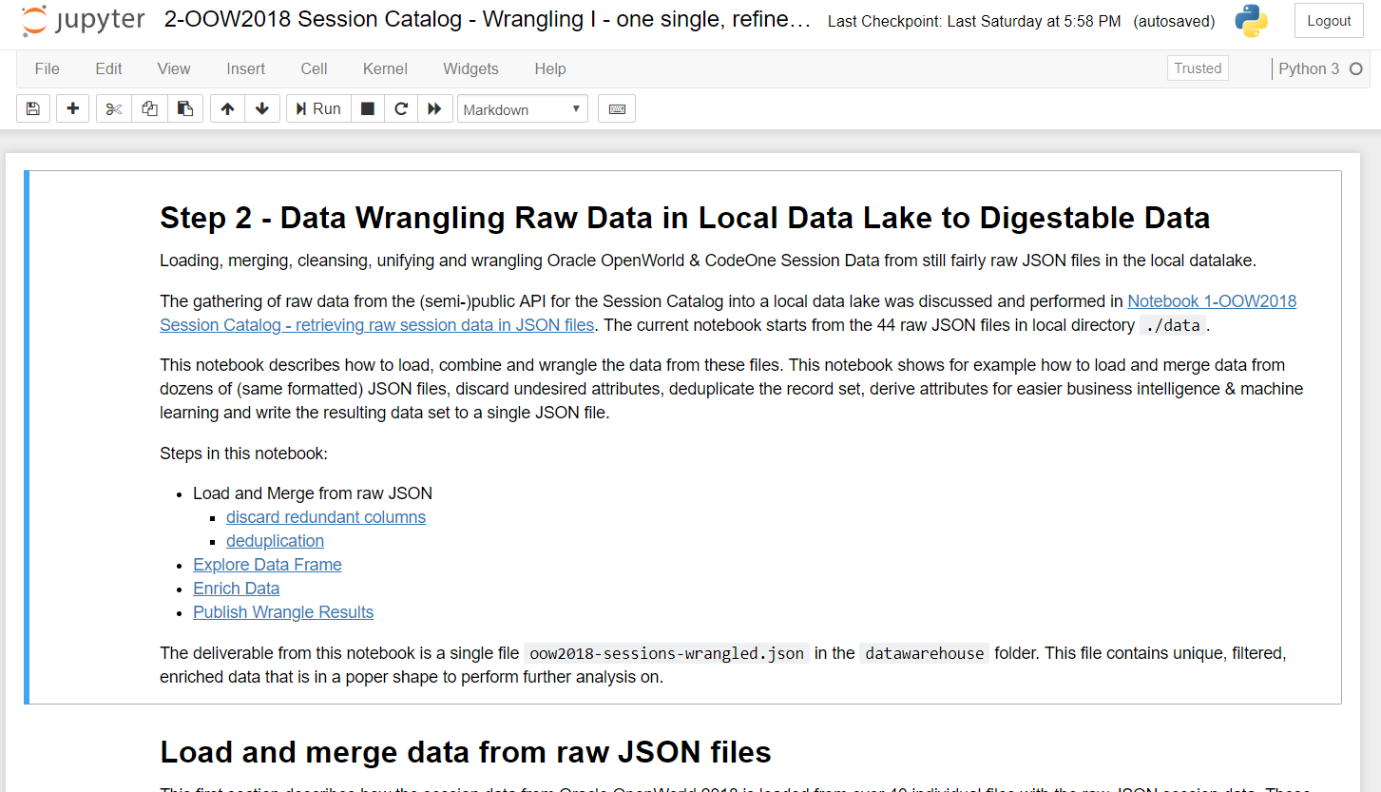

This notebook takes 44 separate JSON files in the Data Lake as its input and produces a single consolidated, cleansed and enriched JSON file as its output. The output set has been rid of unnecessary attributes and has newly engineered features that expose attributes for easy data analytics downstream in the data analytics pipeline.

By browsing or stepping through the notebook, you will some important steps in the Data Wrangling process. The 44 JSON files are loaded into Pandas Data Frames that are subsequently merged into one big Data Frame. This joined Data Frame is explored a little – what are the columns, what are the values in those columns. Then unneeded columns are removed – and the set of records [representing conference sessions] is deduplicated by *session code*. This takes the set down to just over 1700 sessions.

After a little digging around some of the columns in the Data Frame, we look closer at the attributeValues, participants and files columns. Each of these contains a nested JSON object that contains relevant data – albeit in a fairly inaccessible way. We expose these data elements by engineering new features, for example

* a flag indicating whether the session is (co-)presented by an Oracle employee,
* another flag indicating if a file (with the presentation) slides has been uploaded,
* flags for specials speaker designations (such as Oracle ACE Director and Java Champion)
* features for each of three audience levels (beginner, intermediate, advanced) and one for *all* in case all three are marked
* a feature for track(s) to which the session is assigned
* a feature for the number of speakers associated with a session
* a session instance count for the number of times the session is scheduled to take place
* a feature to indicate the room capacity of the (first) room in which the session is scheduled
* features for day, time(slot) and timestamp

Finally, with all these features added to the data set, the data is saved to disk in folder */datawarehouse* as single, consolidated file that is just waiting for data analysts to get their hands on.

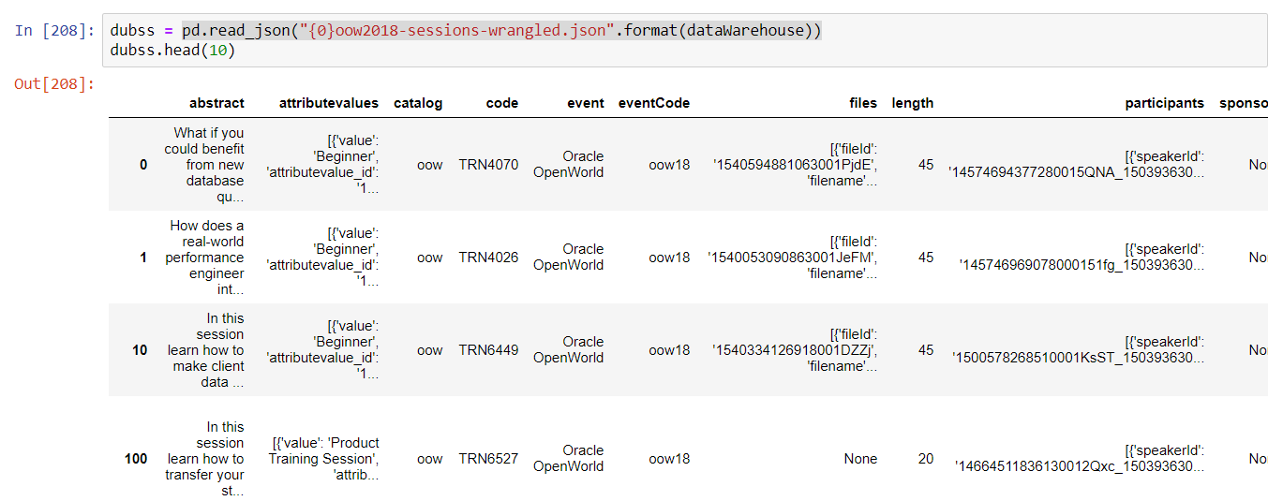

## 3-OOW2018 Session Catalog - Business Intelligence Speakers

The third notebook is the first to leverage the wrangled data, do some additional wrangling and then produce findings, answers on business questions and show some data visualizations.

Load *3-OOW2018 Session Catalog - Business Intelligence Speakers.ipynb* into the Jupyter Notebook client.

Here is a list of all features that our data set contains at this stage

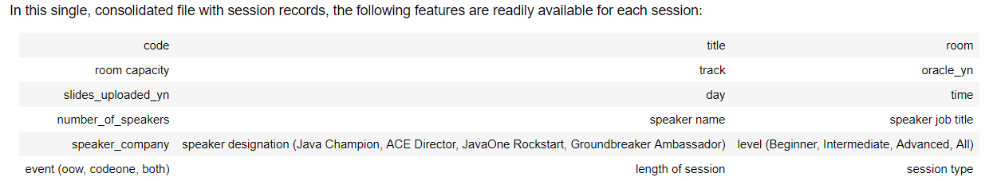

The first step after loading the wrangled dataset from the */datawarehouse* folder is further data preparation: a new Pandas Data Frame *sp* is created with speaker records. These records are produced from the *participants* feature in the sessions data set.

The *sp* data frame has the following features: firstName, lastName, jobTitle, companyName, bio, oracle_employee (special Y/N flag), photoURL, twitter, sessionCount, oow (Y/N flag to indicate if the speaker performs at the Oracle OpenWorld event), codeone (Y/N flag to indicate that the speaker presents a session at CodeOne) and finally four Y/N flag columns for the special designations that speakers can have: 'JavaOne Rockstar', 'Oracle ACE Director', 'Oracle Java Champion', 'Groundbreaker Ambassador'.

The first section in the notebook after the creation of the *sp* Data Frame for speakers is about simple counting: the number of speakers in general and per event. Here we also see te first visualization: a Venn diagram as alternative representation for data earlier presented in a Cross Table.

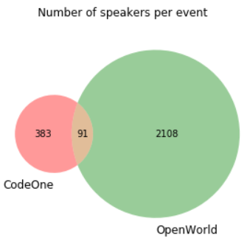

The notebook continues with an analysis of very active speakers. It turns out that one speaker takes part in now fewer than 12 sessions. It turns out that the top 10 of active speakers only has speakers working for Oracle. We then have a cell in the notebook that allows us to look at active speakers per event – for oow and codone respectively. This cell uses an interactive widget – in this case a dropdown list – that allows us to interact with the notebook:

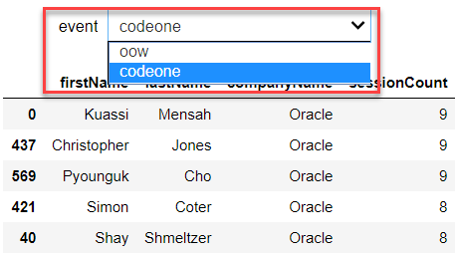

The next section looks at Job Titles. The final visualization in this section uses a Word Cloud to show the most frequently used job titles – for the Oracle OpenWorld and CodeOne events side by side. The difference is striking:

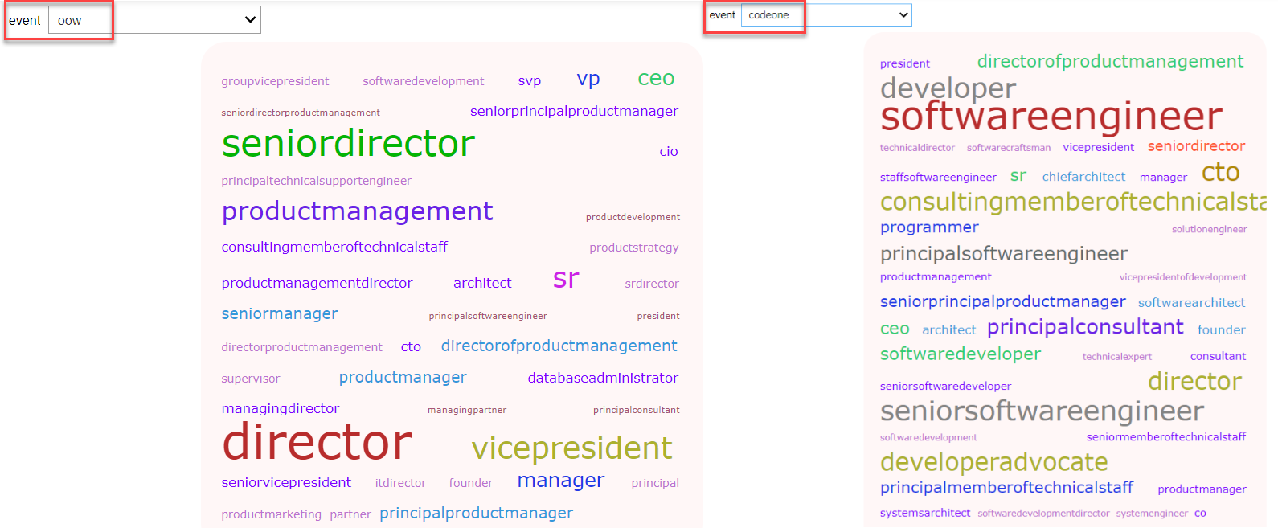

The notebook does a brief analysis of the designations or titles of speakers. It counts the number of speakers per designation and looks at how many speakers have specific combinations of titles. For some people in the community, this is a very important topic.

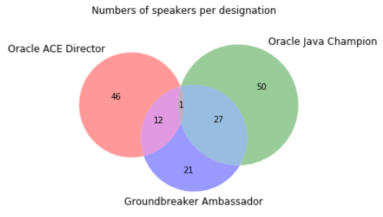

The companies that the speakers are working for is looked at next. It quickly turns out that in the top 10 of companies with the highest numbers of speakers, we find mainly sponsors of the events. Wells Fargo is the first non-sponsor company on the list.

The number of speakers employed by Oracle is very substantial, especially at Oracle OpenWorld:

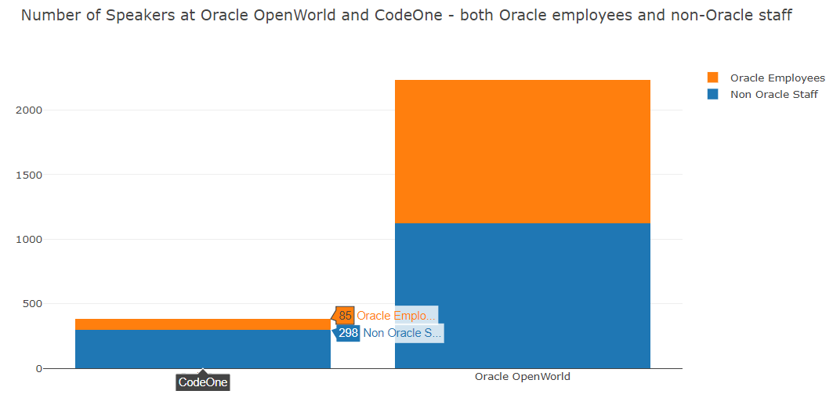

A brief analysis of the incidence of first names quickly reveals that David, John and Michael are the top 3 first names among speakers.

### Gender Guessing

It is interesting to know if women appear as speakers at the two events - given our strive for more *women in tech*. We may be able to stimulate the participation of women if we better understand what type of event attracts female speakers and which tracks perhaps have a higher than average percentage of female speakers. However: our data set does not contain and straightforward gender information. Gender is not a feature of our speaker records.

Does our exploration end before it event started - for lack of data? Or can we be creative? Perhaps we can guess the gender from the first name feature that we do have for all speakers. And check the biographies or gender specific terms such as he and she, his, hum and her. Using these tricks – which turns out to be not very difficult at all - we get a fair idea about the gender distribution and whether there is a significant distinction between Oracle OpenWorld and CodeOne in this regard.

### Create PDF Report from Notebook

It is quite simple to create a PDF report from the notebook. Use File | Download as | PDF via LaTeX (.pdf) to have a PDF rendition downloaded:

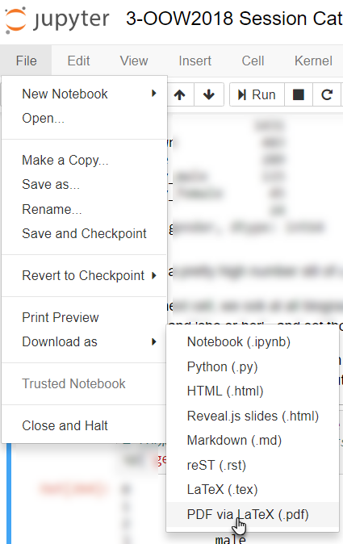

The generated PDF document opens in your browser (or downloads to your browser’s local file system.

Note that many other formats are available as well.

### Running Jupyter Notebooks in the background from the command line

Jupyter Notebooks can be run in the background – for example scheduled to run every day to process the latest available input into output – both the output produced in the cells in the notebook and the representation in the selected format of the executed notebook itself.

On the command line of the Jupyter Notebook server , you can use a command such as the following to run (and convert) a notebook:

jupyter nbconvert --to html --template basic mynotebook.ipynb

In our environment, you can use the following command on the command line terminal – either in the Katacoda environment or locally on your Docker host – to run the step 3 notebook discussed in this section and produce HTML output:

jupyter nbconvert --to html --template basic ~/work/CaseOfOracleOpenWorld2018/'3-OOW2018 Session Catalog - Business Intelligence Speakers.ipynb'

This results in an HTML document being generated; any other side effect caused by the notebook is also created by running the notebook with nbconvert (for example files, API calls, database updates):

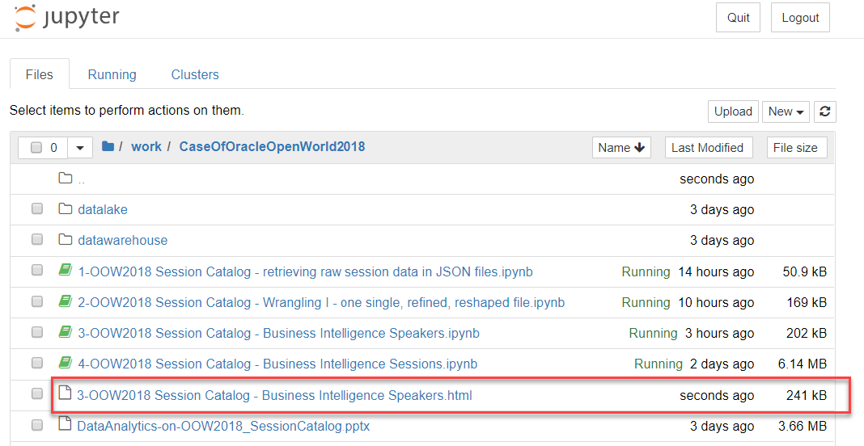

The documentation for nbconvert can be found here: <https://nbconvert.readthedocs.io/en/latest/usage.html>

A notebook can also be downloaded as or converted to executable script – taking only the Code cells and discarding all Markdown cells.

## 4-OOW2018 Session Catalog - Business Intelligence Sessions

In this section, we will analyze data on conference sessions. How many sessions, on which topics, for which levels, and more.

Load *4-OOW2018 Session Catalog - Business Intelligence Sessions* into the Jupyter Notebook client.

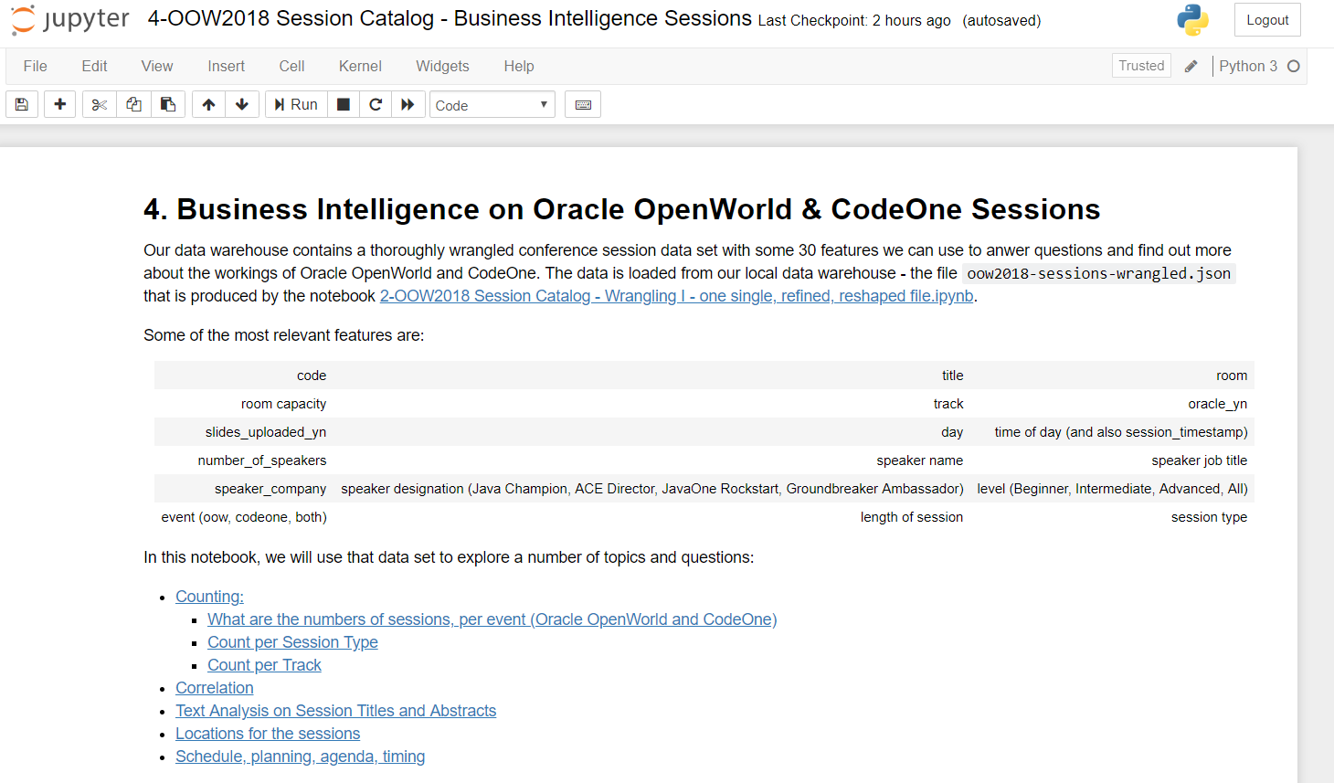

The first part of the notebook loads the wrangled data from file in the *datawarehouse* folder. It then does a little additional wrangling: the session_datetime is constructed as a datetime object from the session_timestamp feature that was read from the file; this feature expresses a timestamp as a number of milliseconds since 1970 – a value that is difficult to work with in data analysis. New features are derived as well: primary_track and secondary_track (from the *track* column) and the *track_count*. A quick describe() on the *ss* dataframe helps us get insight in the numerical columns.

Navigate to the next section on *Session Counting*. There are multiple ways to skin this cat. Using *value_counts()* is the easiest. Using *groupBy()* and aggregation operators such as *size()* – as well as sum, min, max, … - for more advanced ways of counting.

The *plotly* library is integrated into Pandas to allow visualization of data. This histogram shows the numbers of sessions per *session type*.

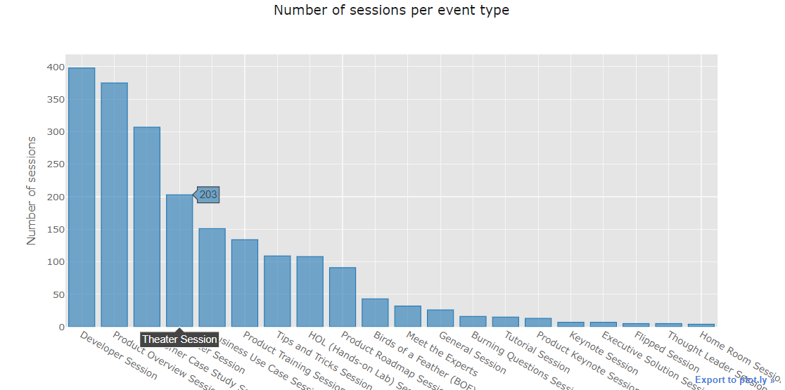

The next cell renders a stacked bar chart that shows the number of sessions per event and per type. The subsequent figure switches event and session type:

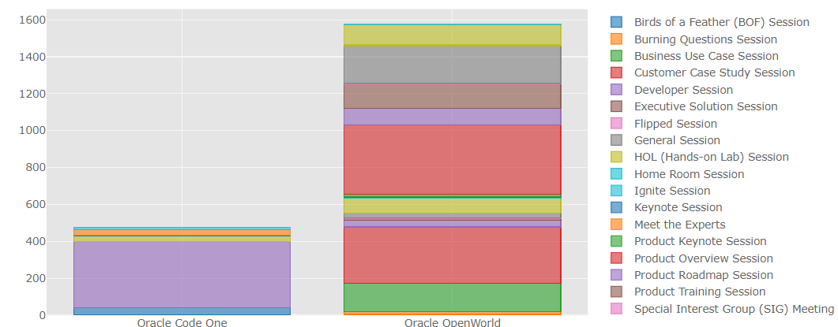

The notebook then shows the number of sessions per catalog: sessions exclusively for Oracle OpenWorld or for CodeOne and a number of sessions listed in both catalogs:

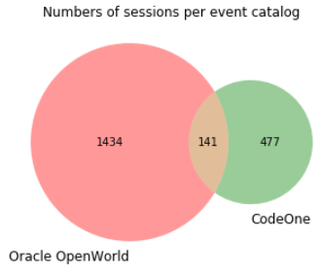

The session counting continues with a brief look at sessions with at least one Oracle speaker – this turns out to be the case very frequently at Oracle OpenWorld. Next, we check out per track: sessions can be associated with tracks and this supposedly helps the attendees find the sessions they like. One may wonder if that works out so well – given the fact that some tracks have one in three sessions associated with them, and others just two or three sessions.

Using a word cloud, we can quickly get a feel for the important tracks (in terms of the numbers of sessions) for the two events.

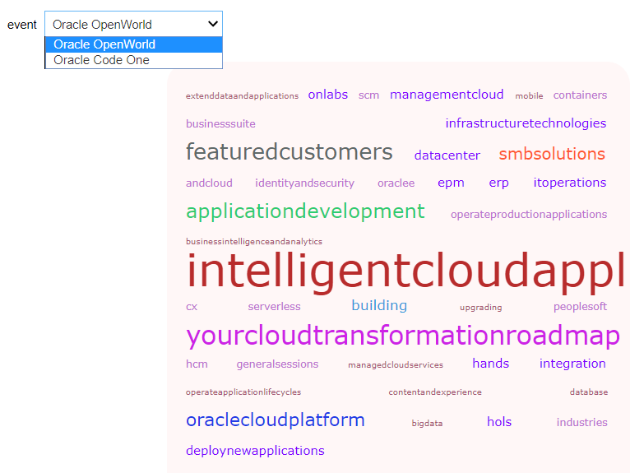

### Correlation

With a Pandas, Python and our Jupyter Notebook, we can easily explore some of the correlations that may hide in our data. We do not say anything about causality- just the somewhat more than average coincidence of values. The notebook demonstrates how to turn some categorical features into numerical values and uses those for a very simple correlation analysis:

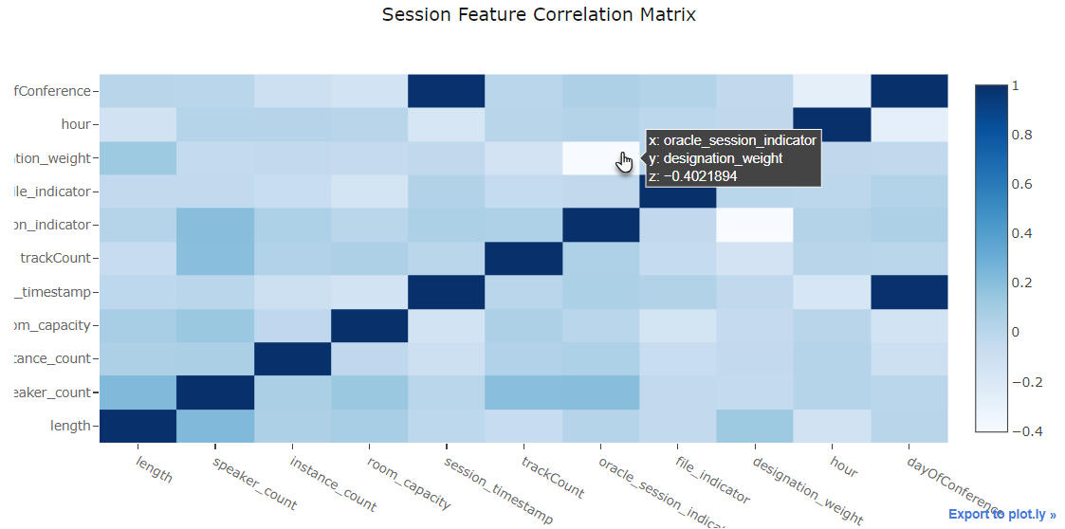

The darker the cell, the higher the correlation between the attributes defining the row and the column. In this figure, we see for example that there is a negative correlation between *designation_weight* and *oracle_session_indicator*. In words: sessions with speakers working for Oracle have fewer speakers with special titles and designations than average sessions do. Which is no surprise, given that Oracle employees cannot have such titles and designations.

You could add these two feature derivations:

ss['titleLength']= ss['title'].apply(len) # the number of characters used in the title (max 80)

ss['abstractLength']= ss['abstract'].apply(len) # the number of characters used in the title (max 750)

And check for correlations. Note the correlation between *designation_weight* and *abstract_length*. Speakers with titles and designations tend to write longer abstracts it would seem. The longer the abstract, the longer the session is another finding.

### Text Analysis of Title and Abstract

A simple text analysis is done of either session titles or session abstracts and presented in a tag cloud. Which terms are frequently used in the titles and abstracts for either Oracle OpenWorld or CodeOne:

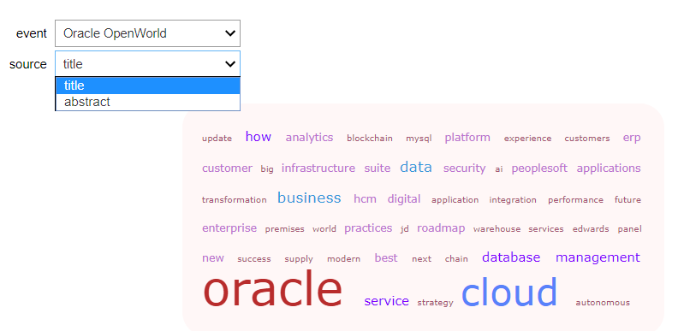

### Venues and Session Locations

From the *room* feature that describes in which room a session takes place, we can derive the seven venues used for the conferences. A new *venue* feature is engineerd.

Subsequently, we can find out about the busiest venues, in terms of rooms and sessions and total room capacity.

### Time is of the essence

The final section in the notebook – before the data frame in its engineered state is saved to the *datamart* – takes a closer look at time: how are the sessions distributed over the days and what are the busy timeslots. It turns out to be quite simple to produce this heatmap to identify the busy slots:

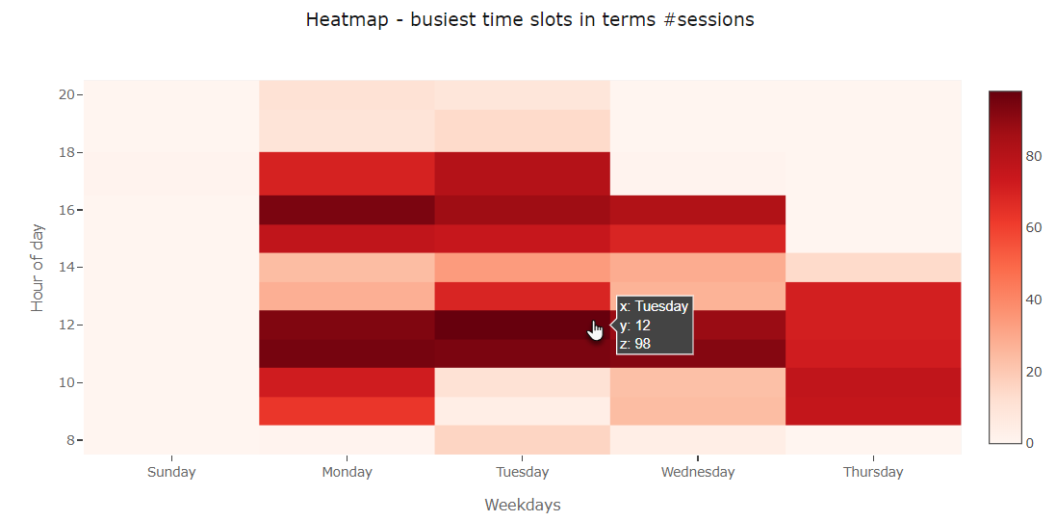A little bit more complex is the Gantt Chart – a common way of presenting the usage of resources (the rooms) through time (for sessions).

## 5-OOW2018 Session Catalog - DIY Business Intelligence on Conference Sessions

The fifth notebook in this series is almost empty. It loads the enriched session data that were created in the fourth notebook from the datamart file into a Pandas Data Frame. At this point – it is up to you. Try and get a little data analysis going on the sessions.

Load *5-OOW2018 Session Catalog - DIY Business Intelligence on Conference Sessions* into the Jupyter Notebook client.

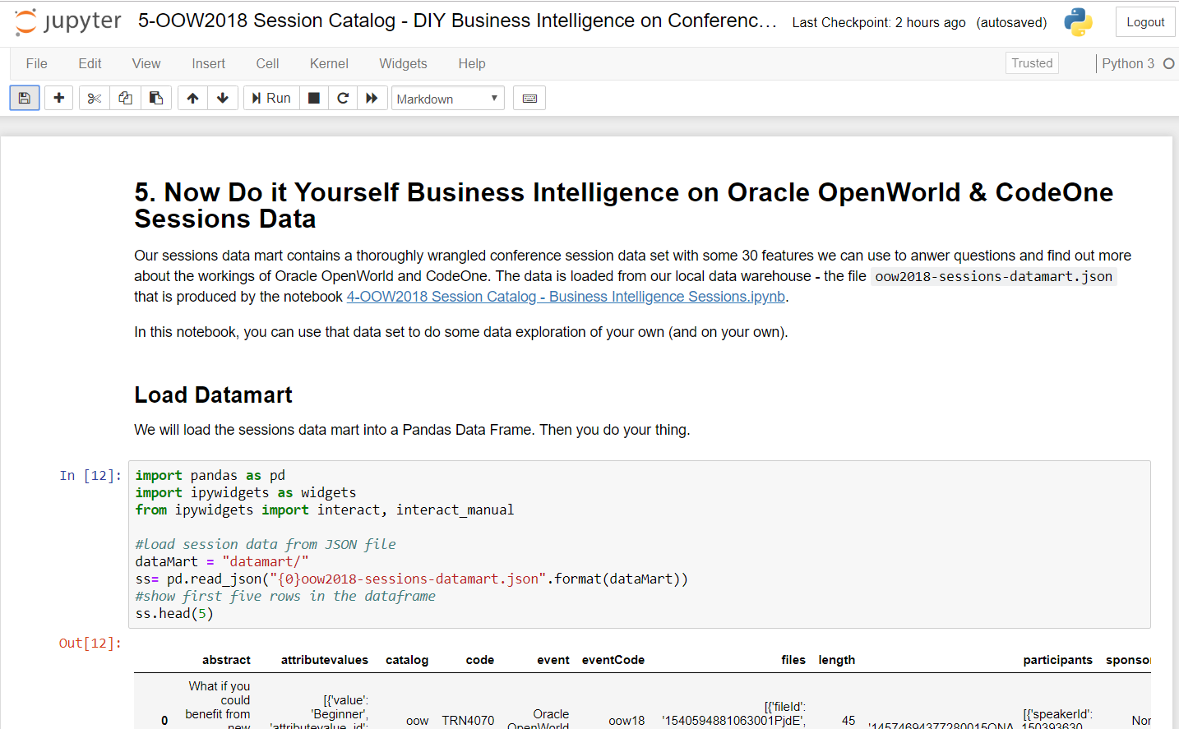

Run the notebook:

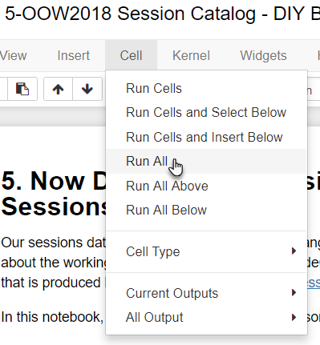

Scroll to the end, to section *Your Data Exploration, Analysis and Visualization*. Now create a new cell. Of type Code (the default).

Then type into the cell:

ss.columns

Then press CTRL+Enter (on Windows) or whatever the shortcut is for running a cell on your platform.

Create a new cell. Type:

ss['type'].value_counts()

and execute the cell. What does this tell you?

Now in the same or another new cell, type:

pd.crosstab(index=ss['catalog'], columns=ss['type'])

and execute the cell. Which Session Type may not make an appearance on Oracle OpenWorld 2019?

# 4. On your own with Titanic: get started on your very own Jupyter Notebook.

Now it is time to create your very own notebook. The Titanic dataset you are going to use is stored in the *Titanic* folder. Create a new Notebook in the same folder by clicking *New ­-> Python 3.* This will create a new Untitled notebook which you can rename in the notebook itself. Remember that if you are working in Katacoda, the notebook is in the cloud and your notebook won’t be stored. If you log out or the container is destroyed, your notebook will be lost!

## Inspect the data

Load the Titanic.csv dataset into your notebook and start investigating the data (use the read_csv function of pandas for this, data is separated by a comma). You will notice the following columns:

|  |  |  |
| --- | --- | --- |
| COLUMN | DESCRIPTION | TYPE |
| PassengerId | ID of passenger | Integer |
| Survived | If passenger survived or not. This will be the classifier to train a model on | Boolean |
| Pclass | Class of travel | Integer |
| Name | Name of passenger | String |
| Sex | Gender | String |
| Age | Age of passenger | Int |
| SibSp | Number of Sibling/Spouse aboard | Int |
| Parch | Number of Parent/Child aboard | Int |
| Ticket | Ticket number | String |
| Fare | Price of ticket | Float |
| Cabin | Cabin number of passengers | String |
| Embarked | The port in which a passenger has embarked. C = Cherbourg, S = Southampton, Q = Queenstown | String |

You can use pyplot in combination with the seaborn library to visually show the data. For example, to show the correlation between class and survival rate use:

import matplotlib.pyplot as plt

import seaborn as sns

sns.barplot(x=“Pclass”,y=“Survived”, data=titanic)

plt.show()

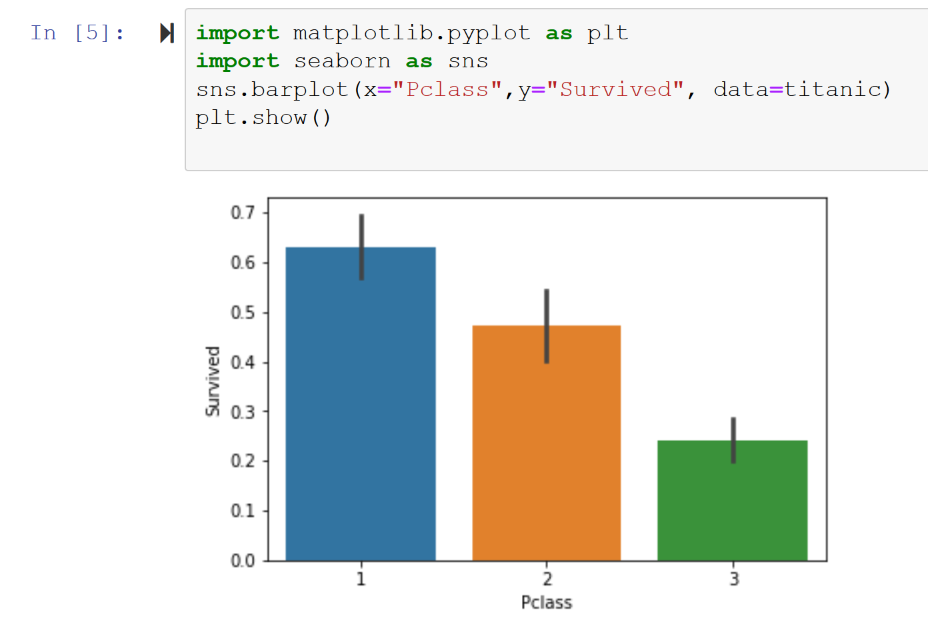

Use this to also look at the correlation between other attributes and see if you can find out something useful.

## Wrangle the dataset

First, check if the data contains missing values. Use the following function to count missing values and see which columns have missing values:

titanic.apply(lambda x: sum(x.isnull()), axis=0)

You will have to deal with missing values. The following common used methods can be used to deal with missing values:

* Drop records
* Drop attributes
* Insert attribute mean for missing values
* Insert attribute median for missing values
* Use regression for insert missing values
* (Or any other statistical method)

Determine yourself which method is suitable for which missing values or try different methods. See section handy functions to transform your data.

Most of the machine learning algorithms (such as SVM, neural networks) only allow numbers as input values. Therefore, all attributes with Strings should be transformed to integer values. Tip, categorize String attributes into int groups, i.e. put all passengers embarked from C into group 1, embarks from S into group 2, and embarks from Q into group 3.

Finally, determine which attributes you think are not useful. These attributes can be dropped. Note that you will have to look carefully at the dataset, since some attributes may not look useful at first but if you look closer it may contain some information. Hint, it may look like that you cannot use the Name attribute since you cannot easily transform it to an integer, but if you look closer at the data it contains some information about the status of the person, ie some persons have a higher status/title (Dr, Capt, Sir, etc). This might have a correlation with the survival rate.

## Test your data

After you have cleaned up your data, it is time to create a model and test the accuracy. Since this is not a workshop on creating models, use the following code to apply a Logistic Regression and a Support Vector Machine on your dataset, adjust the feature_names array to your needs. A value between 0 and 1 is outputted, where a higher number means a better result. Try different modifications on your data and see the effects of it.

from sklearn.svm import SVC

###### PUT ALL ATTRIBUTES YOU WANT TO USE TO CREATE A MODEL IN THIS ARRAY #####

feature_names = ['Sex', 'Age', 'SibSp', 'Parch']

X = titanic[feature_names]

y = titanic['Survived']

# This will split up your dataset into a test and training set

from sklearn.model_selection import train_test_split

X_train, X_test, y_train, y_test = train_test_split(X, y, random_state=0)

# Apply logistic regression on your dataset

from sklearn.linear_model import LogisticRegression

logreg = LogisticRegression()

logreg.fit(X_train, y_train)

print('Accuracy of Logistic regression classifier on training set: {:.3f}'

.format(logreg.score(X_train, y_train)))

print('Accuracy of Logistic regression classifier on test set: {:.3f}'

.format(logreg.score(X_test, y_test)))

# Apply support vector machine on your dataset

from sklearn.svm import SVC

svm = SVC()

svm.fit(X_train, y_train)

print('Accuracy of SVM classifier on training set: {:.3f}'

.format(svm.score(X_train, y_train)))

print('Accuracy of SVM classifier on test set: {:.3f}'

.format(svm.score(X_test, y_test)))

## Some handy Panda functions

All functions which you can apply on your titanic dataset can be found here:

<https://pandas.pydata.org/pandas-docs/stable/reference/api/pandas.DataFrame.html>

Some handy functions you can use, do not forget to assign the result of the functions to the correct column of your dataset or the dataset itself if the function changes the data (assuming you loaded your dataset into the variable titanic):

titanic.shape

dimensions of the dataset

titanic.dtypes

shows the type of each column

titanic["column"].value_counts()

counts the number of records for each unique value in the column

titanic["column"]= titanic["column"].fillna("somevalue")

sets empty values of the column to specified value

titanic["column"]= titanic["column1"].fillna(titanic["column2"].mean())

sets empty values to mean of column

titanic["Sex"] = titanic["Sex"].map({"female": 0, "male": 1})

maps values to other values

titanic = titanic.drop(["column1", "column2"], axis=1)

drops columns

titanic.dropna(subset=["column"], inplace=True)

drop records with no value in column

titanic["Name"].apply(lambda x: x.split(",")[0])

apply a function to each record of the table, this for example gets first name of each person

# Appendix A - Run a Linux VM locally as Docker engine

You may already have a Linux VM with Docker engine running on your laptop. If that is the case, you skip the next section and jump to *Running Jupyter on Docker*. If you currently do not have the capability to run Docker containers, then continue with the next section that will provide pointers for installing Virtual Box, Vagrant and using these two a spinning up a Linux Ubuntu Virtual Machine with Docker engine.

## Installing Virtual Box and Vagrant

Here we will use the combination of VirtualBox and Vagrant to manage one (or more) Linux Ubuntu VM(s) with Docker inside and keep your Windows or Mac OS environment very uncluttered, as visualized in the next figure.

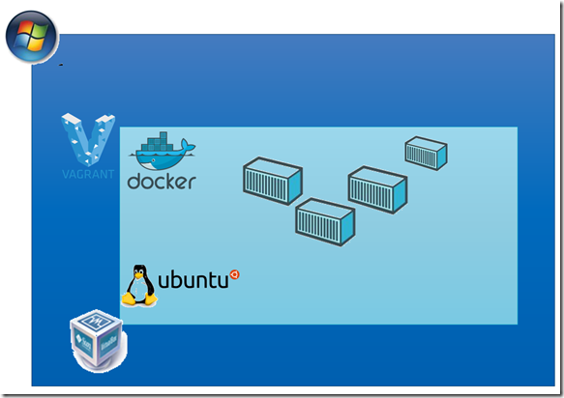

If you currently do not have Oracle Virtual Box installed, please download and install from <https://www.virtualbox.org/wiki/Downloads> .

Next, if you currently do not have Vagrant installed, please download and install from <https://www.vagrantup.com/downloads.html>.

After installing Vagrant, you need to install two vagrant plugins – in order to provide docker-compose into the VM and to allocate a greater than default disk size. Execute these two statements from the command line on your laptop:

vagrant plugin install vagrant-docker-compose

vagrant plugin install vagrant-disksize

## Creating an Ubuntu VM with Docker Host using Vagrant

Open a command line window on your laptop, navigate to the local copy root directory of the GitHub repository you have cloned earlier on; this directory should contain the file Vagrantfile.

Now execute

vagrant up

This statement will launch Vagrant and bring up a new Virtual Machine according to the definition in the Vagrantfile. Feel free to inspect this file.

This step will take quite some time – up to 10 minutes or even longer, depending on how much needs to be downloaded and how fast your network connection is. The good thing is: you do not need to do anything. Just sit back and relax.

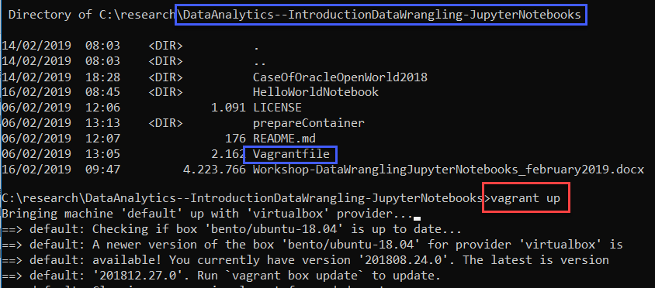

When this command is complete, the Virtual Machine has been provisioned and is running. You can verify this using *vagrant status*. To open a terminal window in the VM, execute – at the same command line as before or at least from within the same directory that contains the Vagrantfile – this command:

vagrant ssh

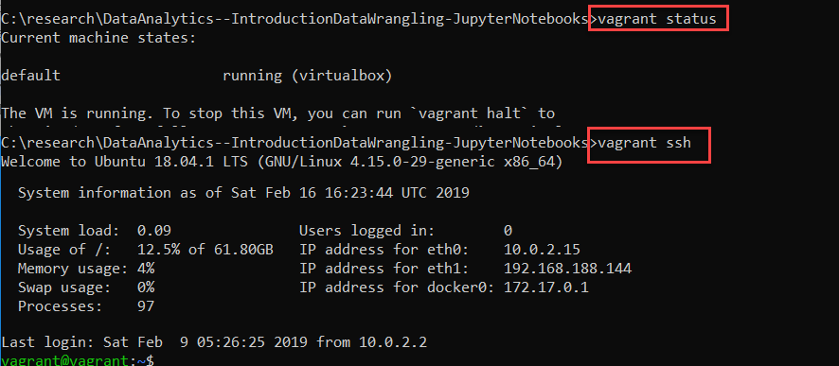

More details on these steps are shown in this article: <https://technology.amis.nl/2018/05/21/rapidly-spinning-up-a-vm-with-ubuntu-and-docker-on-my-windows-machine-using-vagrant-and-virtualbox/>.

The directory on your laptop from which you ran the two vagrant commands has been mapped into the VM automatically, mounted at /vagrant. When you check the contents of /vagrant, you should find several files and directories – especially the directory *prepareContainer*:

ls /vagrant

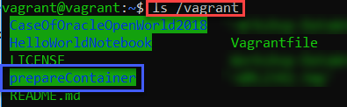

## Running Jupyter on Docker

Here we are. You can run Docker containers. But nothing in your environment is yet Jupyter Notebook or even Python specific. Good. Let’s change that.

I will assume that you are at the command line with Linux at your fingertips and Docker running in the backgroud. docker ps needs to return nothing at this point.

Many container images are available that contain Jupyter Notebooks in some form or shape. I will use the jupyter/scipy -notebook image from [Jupyter Docker Stacks](https://jupyter-docker-stacks.readthedocs.io/en/latest/index.html).The jupyter/scipy -notebook image is fairly rich image. It contains:

* A minimally-functional Jupyter Notebook server
* Miniconda Python 3.6
* Pandoc and TeX Live for notebook document conversion
* git, emacs, jed, nano, and unzip
* pandas, numexpr, matplotlib, scipy, seaborn, scikit-learn, scikit-image, sympy, cython, patsy, statsmodel, cloudpickle, dill, numba, bokeh, sqlalchemy, hdf5, vincent, beautifulsoup, protobuf, and xlrd packages
* ipywidgets for interactive visualizations in Python notebooks
* Facets for visualizing machine learning datasets

We will add a few other libraries on this ‘base’ image.

As first step: run a Docker container based on the image

docker run -p 8888:8888 -d --name jupyter jupyter/scipy-notebook:83ed2c63671f

Note: the Docker image tag (id) is no strictly necessary; if you strip it off (jupyter/scipy-notebook) you will get the latest – which may do everything you need. This particular id is from early February 2019 and it seems to work for me. See all Docker image tags:  <https://hub.docker.com/r/jupyter/scipy-notebook/tags/> .

[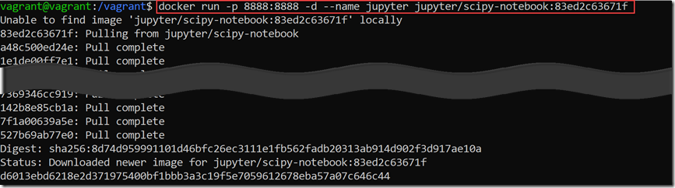](https://technology.amis.nl/wp-content/uploads/2019/02/SNAGHTMLaf6e435.png)

The container image is quite sizable – close to 2 GB. Downloading is bound to take a while – depending on the network capacity you can leverage.

When downloading and extracting is complete for all layers, the container will be running. It exposes port 8888. The Jupyter server is accessible at that port.

[image](https://technology.amis.nl/wp-content/uploads/2019/02/image-45.png)

Access the Jupyter Notebook environment from a browser on your laptop; the endpoint depends on the IP address of the host running the Docker container. In my case, using the Vagrant file in the GitHup repo associated with this article, I will access the Jupyter Notebook at: [http://192.168.188.144:8888](http://192.168.188.144:8888/) .

The Jupyter server will prompt you for a token – to ensure not just anyone can access the environment. Back on the command line, execute this statement:

docker logs jupyter

[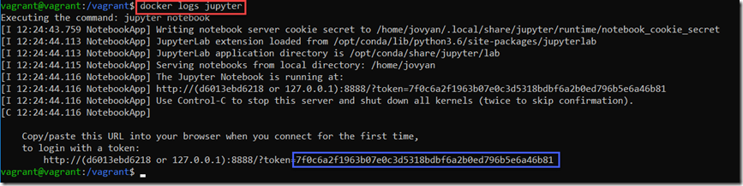](https://technology.amis.nl/wp-content/uploads/2019/02/image-46.png)

This will show something like:

Copy/paste this URL into your browser when you connect for the first time,

to login with a token:

http://localhost:8888/?token=f89b02dd78479d52470b3c3a797408b20cc5a11e067e94b8

The token is the value behind `/?token=`. You need that for logging in.

[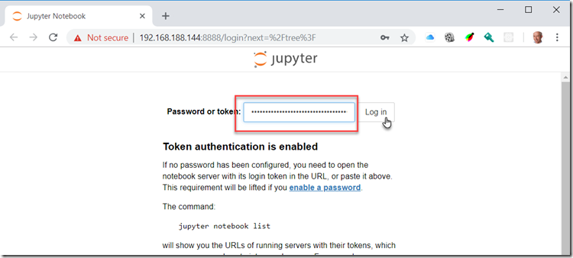](https://technology.amis.nl/wp-content/uploads/2019/02/image-47.png)

After pasting the token, click on the Log In button:

[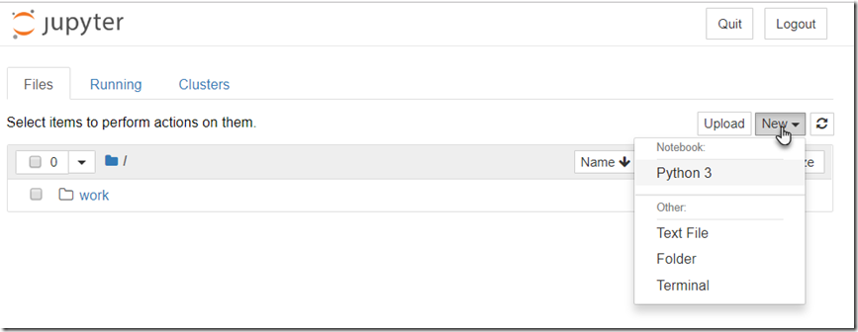](https://technology.amis.nl/wp-content/uploads/2019/02/image-48.png)

At this point, you can start creating your own notebook or upload a notebook from your laptop’s file system. The container currently does not contain any Jupyter Notebooks that we can open and run. We will change this now.

The [GitHub repo](https://github.com/lucasjellema/DataAnalytics--IntroductionDataWrangling-JupyterNotebooks) for this handson that you cloned a little while back has a folder *prepareContainer* that contains two *sh* scripts.

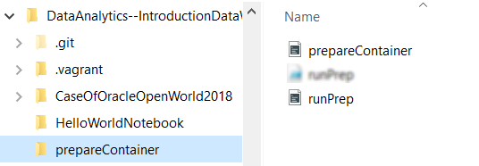

The script *runPrep.sh* copies the script *prepareContainer.sh* into the container and executes it – to install some packages and git clone a few notebooks.

Execute these steps – on the command line of your Docker host – likely from directory /vagrant :

cd prepareContainer

./runPrep.sh

The script prepareContainer.sh is copied into the container and made executable. Then it is executed. It installs various Python packages using *pip* and git clones Jupyter notebooks into the container.

[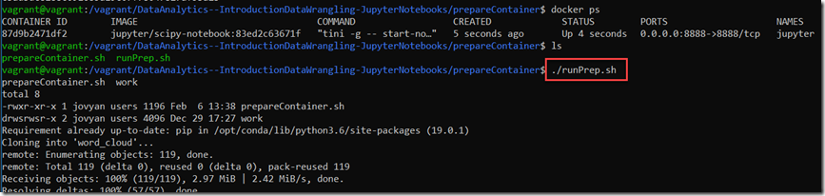](https://technology.amis.nl/wp-content/uploads/2019/02/image-51.png)

When the actions inside the container are done – note: this can take a few minutes – the container is restarted to have the Jupyter Notebook server pick up all changes. You may need a new token from the restarted server to login to the Jupyter Notebook environment in the browser.

[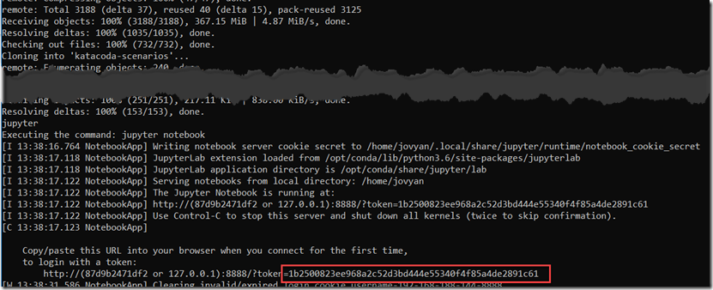](https://technology.amis.nl/wp-content/uploads/2019/02/SNAGHTMLb3a7a07.png)

When you next enter the Jupyter Notebook environment in the browser, you will see a number of notebooks that were not there before.

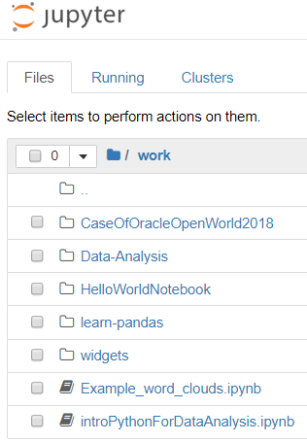

For example: open and run introPythonForDataAnalysis.ipynb in the work folder. Or open and run Example_word_clouds.ipynb.

# Appendix B - Run Docker using Docker for Windows

This instruction assumes that you are able to run Docker container from the Windows command line. And that you have opened a Powershell command line terminal. Navigate to the root of the GitHub repository clone – the directory that contains the file README.md and a subdirectory *prepareContainer*.

Nothing in your environment is yet Jupyter Notebook or even Python specific. Good. Let’s change that.

Many container images are available that contain Jupyter Notebooks in some form or shape. I will use the jupyter/scipy -notebook image from [Jupyter Docker Stacks](https://jupyter-docker-stacks.readthedocs.io/en/latest/index.html).The jupyter/scipy -notebook image is fairly rich image. It contains:

* A minimally-functional Jupyter Notebook server
* Miniconda Python 3.6
* Pandoc and TeX Live for notebook document conversion
* git, emacs, jed, nano, and unzip
* pandas, numexpr, matplotlib, scipy, seaborn, scikit-learn, scikit-image, sympy, cython, patsy, statsmodel, cloudpickle, dill, numba, bokeh, sqlalchemy, hdf5, vincent, beautifulsoup, protobuf, and xlrd packages
* ipywidgets for interactive visualizations in Python notebooks
* Facets for visualizing machine learning datasets

We will add a few other libraries on this ‘base’ image.

As first step: run a Docker container based on the image

docker run -p 8888:8888 -d --name jupyter jupyter/scipy-notebook:83ed2c63671f

Note: the Docker image tag (id) is no strictly necessary; if you strip it off (jupyter/scipy-notebook) you will get the latest – which may do everything you need. This particular id is from early February 2019 and it seems to work for me. See all Docker image tags:  <https://hub.docker.com/r/jupyter/scipy-notebook/tags/> .

The container image is quite sizable – close to 2 GB. Downloading is bound to take a while – depending on the network capacity you can leverage.

When downloading and extracting is complete for all layers, the container will be running. It exposes port 8888. The Jupyter server is accessible at that port.

Access the Jupyter Notebook environment from a browser; with Docker for Windows, you can probably just point your browser a <http://localhost:8888> .

The Jupyter server will prompt you for a token – to ensure not just anyone can access the environment. Back on the command line, execute this statement:

docker logs jupyter

[](https://technology.amis.nl/wp-content/uploads/2019/02/image-46.png)

This will show something like:

Copy/paste this URL into your browser when you connect for the first time,

to login with a token:

http://localhost:8888/?token=f89b02dd78479d52470b3c3a797408b20cc5a11e067e94b8

The token is the value behind `/?token=`. You need that for logging in.

[](https://technology.amis.nl/wp-content/uploads/2019/02/image-47.png)

After pasting the token, click on the Log In button:

[](https://technology.amis.nl/wp-content/uploads/2019/02/image-48.png)

At this point, you can start creating your own notebook or upload a notebook from your laptop’s file system. The container currently does not contain any Jupyter Notebooks that we can open and run. We will change this now.

The [GitHub repo](https://github.com/lucasjellema/DataAnalytics--IntroductionDataWrangling-JupyterNotebooks) for this handson that you cloned a little while back has a folder *prepareContainer* that contains two *sh* scripts and a Powershell script.

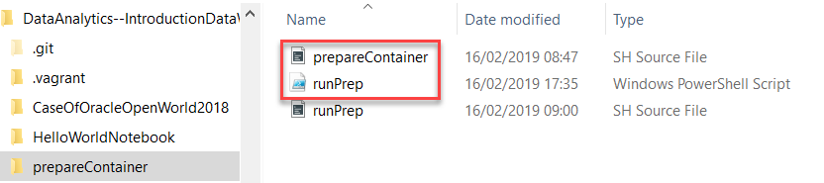

The script *runPrep.ps1* copies the script *prepareContainer.sh* into the container and executes it – to install some packages and git clone a few notebooks.

Execute these steps:

cd prepareContainer

./runPrep.ps1

The script prepareContainer.sh is copied into the container and made executable. Then it is executed. It installs various Python packages using *pip* and git clones Jupyter notebooks into the container.

When the actions inside the container are done – note: this can take a few minutes – the container is restarted to have the Jupyter Notebook server pick up all changes. You may need a new token from the restarted server to login to the Jupyter Notebook environment in the browser.

[](https://technology.amis.nl/wp-content/uploads/2019/02/SNAGHTMLb3a7a07.png)

When you next enter the Jupyter Notebook environment in the browser, you will see a number of notebooks that were not there before.



For example: open and run introPythonForDataAnalysis.ipynb in the work folder. Or open and run Example_word_clouds.ipynb.

# Appendix C - Cloud based Jupyter Notebook Playground using Katacoda



Katacoda is an online platform that offers hundreds of scenarios and sandbox environments to learn about and play with different kinds of technologies. Katacoda is special in that it not only offers the handson instructions – it also provides the runtime environment in which these steps can be executed instantly. Examples of such environments: Linux server, Docker engine, Kubernetes cluster and almost anything that can be run as container. I have created a Katacoda scenario for Jupyter Notebook – with a number of handpicked Python libraries and a Notebook git cloned from GitHub; with all the resources we need for our workshop.

In order to get your running Jupyter Notebook environment, you have to take these steps:

1. Go to <https://www.katacoda.com> and sign up – using your GitHub account.

2. Open your browser at <https://www.katacoda.com/lucasjellema/scenarios/jupyter-notebook>

You will come to a page that looks like this figure:

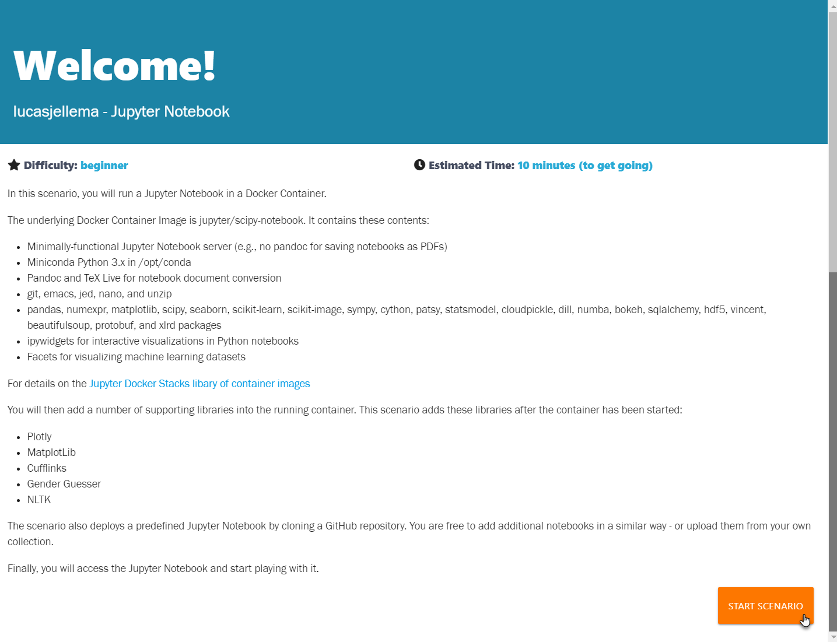

3. Click on the button *Start Scenario*

4. Follow the instructions in Step 1

The first step in the scenario looks as shown in the next figure.   
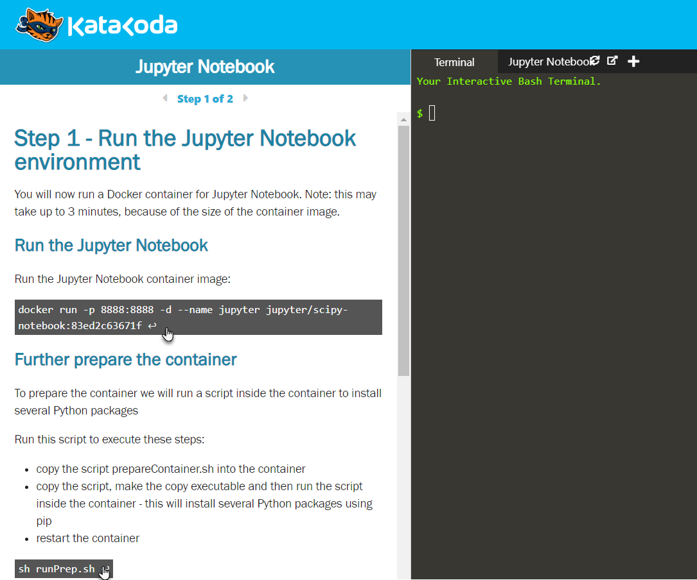  
You have to click twice – to have two key commands executed that will configure your environment:

1. Click on the first dark gray area that contains a command starting with *docker run*. By clicking on this command, you cause it to be copied to the terminal window shown on the right where it is immediately executed.  
     
   This command instructs the Docker container engine to start the indicated container image jupyter/scipy-notebook. Because that image is not available yet, it needs to be downloaded. This will take some time (the download size is around 2 GB) – typically 2-4 minutes.   
   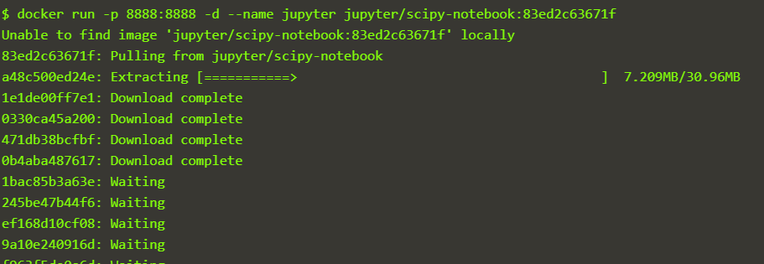  
     
   When the container is running – the terminal will show something like this:  
   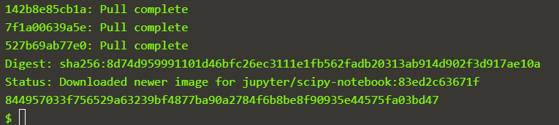  
   If you feel brave, you could type a little something into the terminal window, for example: *docker ps*. This requests the Docker engine to show a list of all running containers:  
   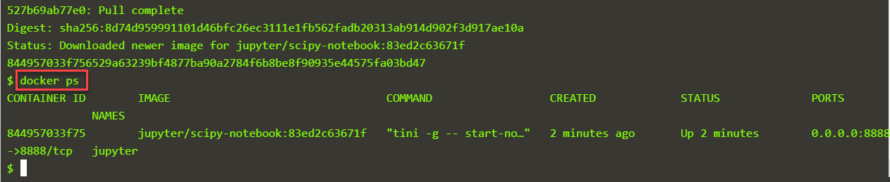
2. Click on the second gray area – containing a command *sh runPrep.sh*. This command will copy and execute a script. This script will do a number of things. This all contributes to making sure the container contains all required resources. Note: running this script will also take considerable time – another 2-4 minutes is typical.   
     
   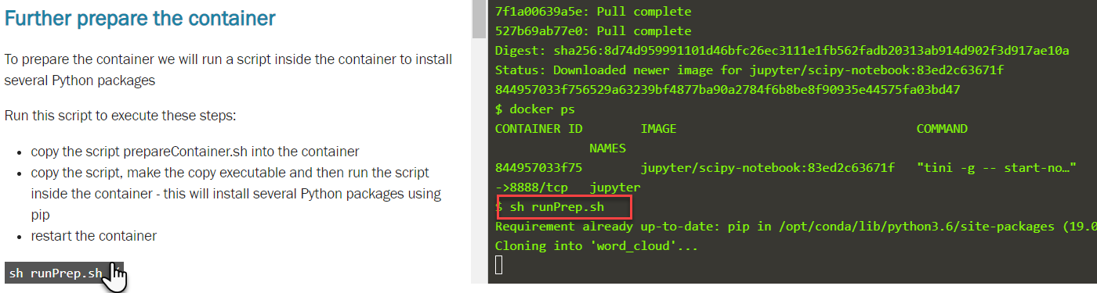  
   When the script is complete – it will restart the Docker container to ensure all changes take effect.   
   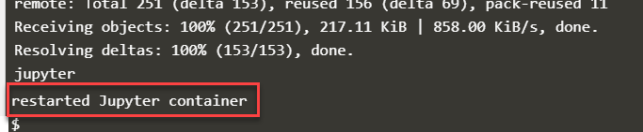  
     
     
   Now you can proceed to ***step 2*** in the scenario.

5. Perform the tasks in Step 2 in the Katacoda scenario

In Step 2, you will access the Jupyter Notebook server that is running at this point. In order to access the environment in a browser, we need a token. We can read the token from the log-files produced in the container. Click on the next code block – that contains *docker logs jupyter* -- to retrieve these logs. The logs are shown in the terminal and they will contain the token we need:

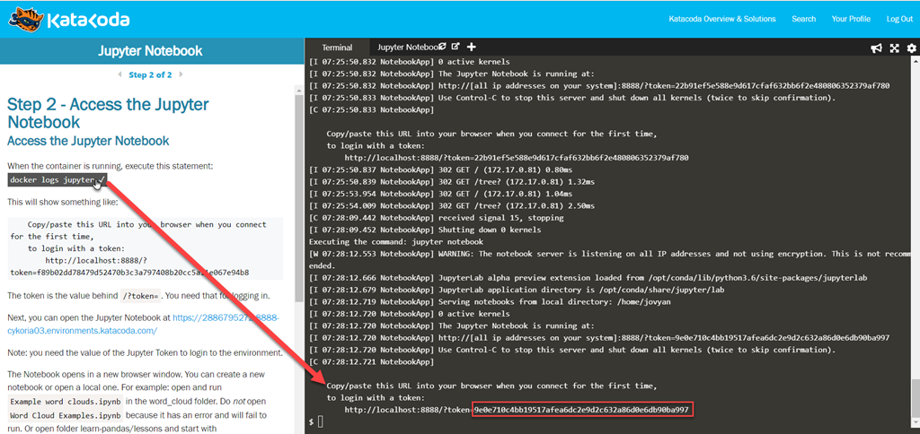

Copy the token shown in the terminal to the clipboard.

Click on the tab Jupyter Notebook – or the link in the text on the left hand side – to open the Jupyter Notebook web console. Paste in the token and press Login:

[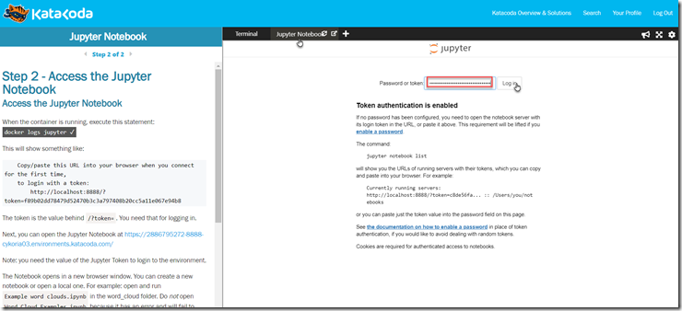](https://technology.amis.nl/wp-content/uploads/2019/02/image-21.png)

This will open the Jupyter web environment. Open for example the preloaded notebook Example Word Cloud (from File | Open), click on Cell | Run All and see the result:

[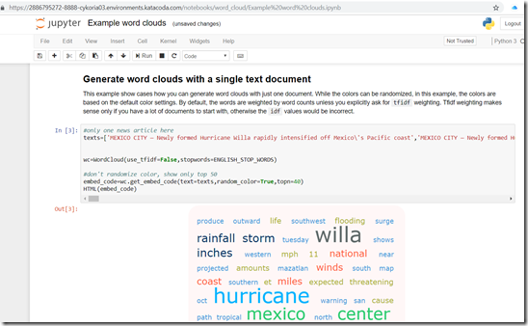](https://technology.amis.nl/wp-content/uploads/2019/02/image-22.png)

Now you are ready for the next assignment.

Note: [this blog article](https://technology.amis.nl/2019/02/03/creating-a-katacoda-scenario-a-tailor-made-on-line-tutorial-environment-for-example-for-jupyter-notebook/) explains in detail how this playground was set up on Katacoda as a scenario. You will find that the scenario contains almost the same steps as are used for the local installation. You can also create your own Katacoda scenarios, for Jupyter Notebook, other data analytics activities as well as virtually anything you can run on a standard Linux environment.